Lab 1: Understanding ORM with a Retail Inventory System
Step1: What is ORM?
ORM is known as Object-Relational Mapping which lets you interact with database tables using C# classes. A class becomes a Table, and a Property becomes a Column.
The benefits are as stated below –
- Faster development (no manual SQL strings needed).
- Easier code maintenance.
- Databases can be switched without changing C# logic.
Step 2: EF Core vs EF Framework -
EF Core is cross-platform which runs on Windows, Mac, Linux. It is fast, lightweight and supports modern cloud architecture.
EF Framework or EF6 is older, heavy, legacy version which is only restricted strictly to Windows environments.
Step 3: EF Core 8.0 Features –
- JSON Mapping: Maps complex C# objects directly into a single database JSON column.
- Compiled Models: Speeds up application startup times for large database schemas.
- Bulk Operations: Updates or deletes thousands of database rows efficiently without loading them into memory first.
Step 4: Creating a .NET Console App –
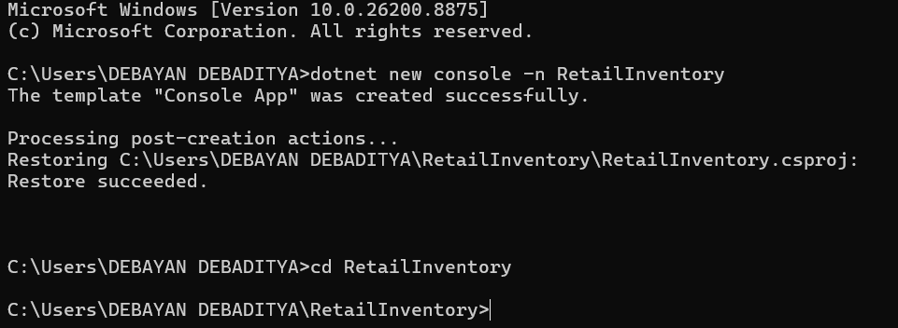
Step 5: Installing EF Core Packages
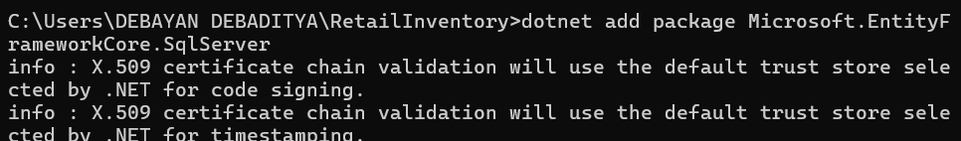
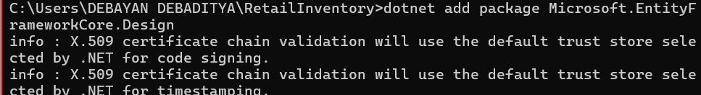
Code:
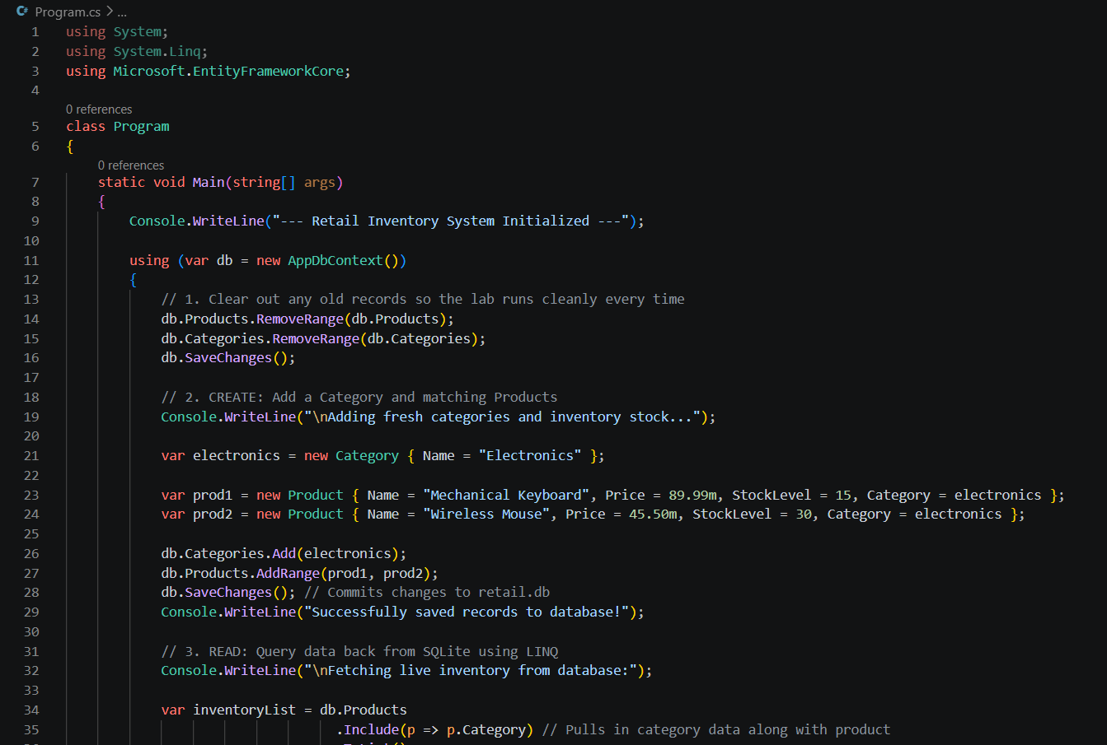
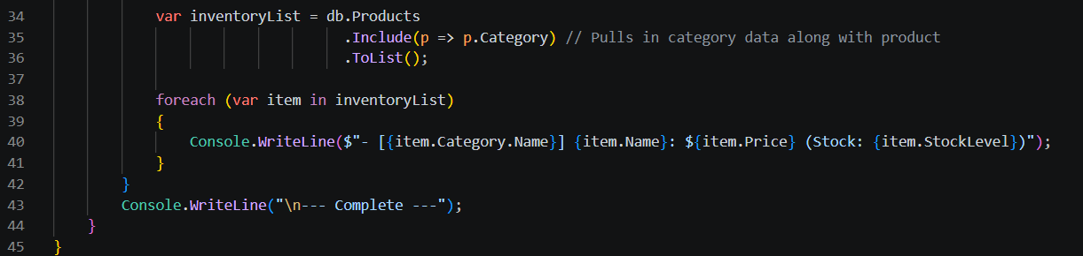

Output:
